| Akatek new Casino Launch Template  Version 0.1 |
| --- |

04 / 2014

Table of Contents

Purpose and Overview 3

Document purpose 3

Overview of topics 3

Contact details, integration servers and websites 4

Contact details form 4

Customer integration system details 4

Client graphics and customization 5

Integration and reporting functions 8

Integration API 8

Kiosk management system access details 8

Kiosk management system 9

Top Level Entity 10

Top Level Admin 10

Business Structures Entity 10

Business Structure 10

Kiosk admin 10

Kiosk 10

Player data synchronization 11

Creating a new Player account 11

Reading account information 13

Changing account information 14

Checking if player is online or has existing session 15

Casino chips transfer 16

Transferring chips into a player account 16

Transferring chips out of a player account 18

Check transaction status 20

Reporting API functions 21

Get all custom reports 21

Get report form 21

Kiosk API reports 22

KioskAdmin 22

KioskTransaction 22

Document summary 23

## Purpose and Overview

### Document purpose

The purpose of this document is to describe the launch process and required information for any new Casino brand.

### Overview of topics

This document will cover the below topics:

* Contact details, integration servers and websites
* Client graphics and customization
* Integration API and process flow
* Game limits and VIP levels
* Additional documents

## Contact details, integration servers and websites

### Contact details form

In order for us to serve you better please fill in the below contact details form.

|  |  |  |  |
| --- | --- | --- | --- |
| Name | E-mail | Skype | Position/Role |
| Support | Please fill in | Fill in | Please fill in |
| PM | Project manager, fill in | Fill in | Please fill in |
| Operatios | Operations contact, fill in | Fill in | Please fill in |
| Developer | Developer contract, fill in | Fill in | Please fill in |

### Customer integration system details

It is required to document in our system all IP addresses for Customer side API servers for data integration and websites for flash platform to work. Please fill in the below form with the required details.

**Licensee integration server IP addresses:**

|  |  |
| --- | --- |
| Server IP address | Server location country |
|  |  |
|  |  |
|  |  |
|  |  |
|  |  |
|  |  |
|  |  |
|  |  |
|  |  |
|  |  |
|  |  |

**Licensee websites from where Casino games are launched from:**

|  |  |
| --- | --- |
|  |  |
|  |  |
|  |  |
|  |  |
|  |  |

## Client graphics and customization

We are offering the possibility to customize the below in our offered download client:

1. Customers logo in the download client lobby
2. Customers background in the download client lobby
3. Customers logo as the desktop icon
4. Customers logo in the casino installer icon
5. Customers logo in the casino installer menu
6. Customers logo in the casino installer wizard

In order for us to facilitate the graphics we will need to receive from the customer the below images:

1. 230 x 86 pixels transparent background PNG file for the logo in the lobby
2. 1440 x 900 pixels solid background PNG file for the background of the lobby
3. 48 x 48 pixels transparent or solid background PNG file for the desktop icon
4. 48 x 48 pixels transparent or solid background PNG file for the installer icon
5. 165 x 315 pixels solid background PNG file for the installer menu
6. 55 x 58 pixels solid background PNG file for the installer wizard

Please see below the examples of the images:

1. Icon  
     
   
2. Installer language selection  
     
   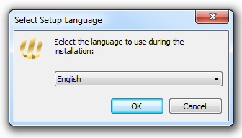
3. Installer with the customizable wizard image  
     
   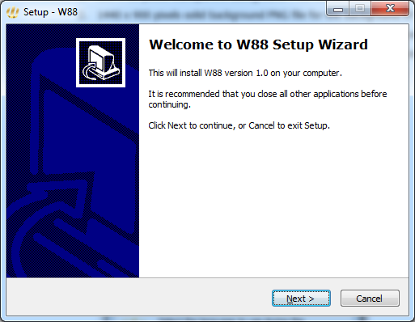
4. Customized desktop icon  
     
   
5. Default, non-customizable client download screen  
     
   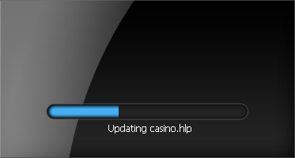
6. Default, non-customizable client login screen  
     
   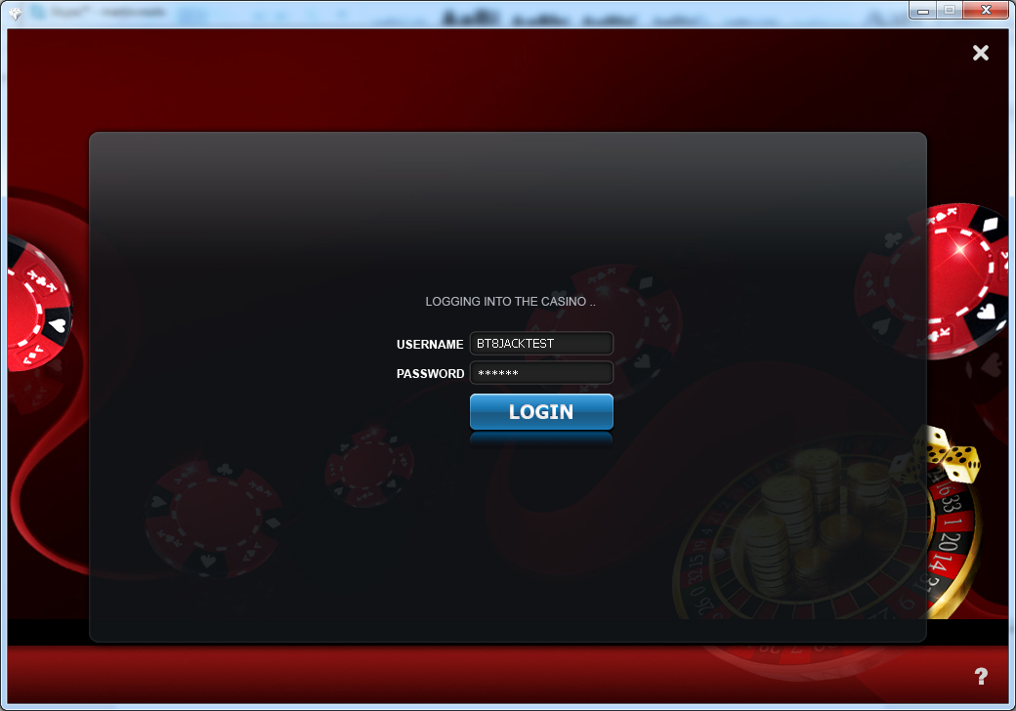
7. Customized logo (green highlight) and background (red highlight) in the casino lobby  
     
   

## Integration and reporting functions

We are using an HTTP based integration system where all integration API calls are sent to our system from the Customers environment over SSL. Our system utilizes a high-level security and automated internal security mechanisms to enhance the integrity and validity of our environment.

SSL security certificates for the integration will be provided to you separately upon the completion of activating the integration and management accounts.

### Integration API

**Integration server URL:** https://kioskpublicapi.redhorse88.com/

* **Player functions**

**Function to create players:**  createPlayer

**Function to read player info:**  getPlayerInfo

**Function to update player account:**  updatePlayer

**Function to check if player is online:**  isPlayerOnline

**Function to deposit to player account:**  deposit

**Function to withdraw from player account:** withdraw

**Function to check status of transaction:** checktransaction

* **Mass functions**

**Function to mass create player accounts:** massCreatePlayers

**Function to mass disable player accounts:** massFreezePlayers

**Function to mass deposit into player accounts:** massDepositPlayers

* **Reporting functions**

**Function to show kiosk structure:**  getKiosks

**This is a fun action to be used many times:** getallcustomreports

**Function to call a report for data:**  getReport

**This is a fun action to be used many times:** getReportForm

### Kiosk management system access details

**Kiosk management URL:**  https://kiosk.yourdomain.com/

**Kiosk admin user name:** ******

**Kiosk admin password:** ******

### Kiosk admin

A kiosk admin is an admin account that owns and manages players directly under itself.

### Kiosk

A kiosk is a virtual container that holds player accounts. Every kiosk must be under an entity and must belong to one or more kiosk admins.

For further information and training on the Kiosk system please contact your Account Executive.

## Player data synchronization

Player data synchronization is required as a basis of all other integration parts for our platform. Our integration system requires that a valid user name and password exists in our platform database to authenticate users into the system and the keep the mandatory user information up to date.

### Creating a new Player account

Users can be created via our Integration API call functions in createPlayer API call. When creating user accounts please note that all user names must be in UPPER CASE and a prefix designated in the account details for the user should be used to simplify user management and to avoid overlapping user names within the environment.

#### Example API call to create new account

This example URL includes all mandatory input parameters and for user accounts to be created.

Example: https://kioskpublicapi.redhorse88.com/createPlayer/SSCASINO0001/seoulcasino1/ seoulcasino1/password/qwerty

All input parameters have been given below.

|  |  |  |  |
| --- | --- | --- | --- |
| Parameter name | Type | Comments | Mandatory |
| playername | string | Player username | yes |
| kioskadminname | string | kiosk admin name | yes |
| kioskname | string | kiosk name | yes |
| firstname | string | firstname | no |
| lastname | string | lastname | no |
| countrycode | string | countrycode | no |
| city | string | city | no |
| zip | string | zip | no |
| address | string | address | no |
| state | string | state | no |
| phone | string | phone | no |
| fax | string | fax | no |
| email | string | email | no |
| comments | string | comments | no |
| birthdate | string | birthdate | no |
| viplevel | string | viplevel | no |
| language | string | language | no |
| sex | string | sex | no |
| password | string | password | no |
| customFieldsFromStructure | string | customFieldsFromStructure | no |
| (yes/no) | string | (yes/no) | no |
| custom01...20 | string | custom01...20 | no |

#### New account creation process example

A proper flow of procedures should be executed during the new account creation process to ensure that the accounts are properly created over the API. Below are two example flows of the process.



**Diagram 2. New account registration process**



**Diagram 3. Existing account synchronization process**

### Reading account information

Account information retrieval can be done over getPlayerInfo API call. This could be required for a number of reasons, including but not limited to: to check if account exists, to check if account is in good state, to check account balance over API.

#### Example API verify account details

This example URL includes all mandatory input parameters and for user accounts information to be red.

Example: https://kioskpublicapi.redhorse88.com/getPlayerInfo/SSCASINO0001/

All input parameters have been given below.

|  |  |  |
| --- | --- | --- |
| Parameter name | Limits / Requirements | Mandatory |
| player | string | yes |

#### Reading account information process example

A proper flow of procedures should be executed to get/show basic player information.



**Diagram 4. Reading basic account information**

### Changing account information

Our API can be used to change the Player account VIP level (betting limits), to force disconnect the user from our gaming system and to deactivate/activate the user account.

#### Example API call to change Player account details

This example URL includes all mandatory input parameters and for user accounts information to be updated.

Example: https://kioskpublicapi.redhorse88.com/updatePlayer/SSCASINO0001/password/123456

All input parameters have been given below.

|  |  |  |  |
| --- | --- | --- | --- |
| Parameter name | Type | Comments | Mandatory |
| playername | string | Player username | yes |
| firstname | string | firstname | no |
| lastname | string | lastname | no |
| countrycode | string | countrycode | no |
| city | string | city | no |
| zip | string | zip | no |
| address | string | address | no |
| state | string | state | no |
| phone | string | phone | no |
| fax | string | fax | no |
| email | string | email | no |
| comments | string | comments | no |
| birthdate | string | birthdate | no |
| viplevel | string | viplevel | no |
| language | string | language | no |
| sex | string | sex | no |
| password | string | password | no |
| customFieldsFromStructure | string | customFieldsFromStructure | no |
| (yes/no) | string | (yes/no) | no |
| custom01...20 | string | custom01...20 | no |

### Checking if player is online or has existing session

Checking if the player is online or has existing session can be done over isPlayerOnline API call. This function should be used to check if the account is online before allowing the player to submit a new login request.

#### Example API verify account details

This example URL includes all mandatory input parameters and for user accounts information to be red.

Example: https://kioskpublicapi.redhorse88.com/isPlayerOnline/SSCASINO0001/

All input parameters have been given below.

|  |  |  |
| --- | --- | --- |
| Parameter name | Limits / Requirements | Mandatory |
| player | string | yes |

#### Reading account information process example

A proper flow of procedures should be executed to get/show basic player information.



**Diagram 5. Checking for and removing active session**

## Casino chips transfer

Our API provides simple functionality to deposit and withdraw funds from user accounts.

### Transferring chips into a player account

For transferring chips into the player account, the deposit API call should be used. Please note that the players are funded from the Kiosk Admin balance and the Kiosk Admin needs to have enough funds for the transaction to pass in the system.

#### Example API call to transfers chips into the casino

This example URL includes all mandatory input parameters to make a deposit request.

Example: https://kioskpublicapi.redhorse88.com/deposit/SSCASINO0001/1/seoulcasino1/externaltranid/123456

#### Input parameters

|  |  |  |  |
| --- | --- | --- | --- |
| Parameter name | Type | Comment | Mandatory |
| playername | string | player username | yes |
| amount | float | amount to deposit | yes |
| kioskadminname | string | kiosk admin name | yes |
| externaltranid | string, AlphaNum(0-200) | external tracking ID | no |

#### Making a deposit process example

A proper flow of procedures should be executed to make a deposit into the players account.

NB! This is only a suggested process flow, the actions done inside the Casino Website should be carefully evaluated and tested by the website owner.



**Diagram 6. Making a deposit**

### Transferring chips out of a player account

For transferring chips out of the player account, the deposit API call should be used. Please note that the players are withdrawn into the Kiosk Admin balance and the Kiosk Admin balance will increase relative to the withdrawal amount from the players balance.

#### Example API call to transfers chips into the casino

This example URL includes all mandatory input parameters to make a withdrawal request.

Example: https://kioskpublicapi.redhorse88.com/withdraw/SSCASINO0001/1/seoulcasino1/externaltranid/654321

#### Input parameters

|  |  |  |  |
| --- | --- | --- | --- |
| Parameter name | Type | Comment | Mandatory |
| playername | string | player username | yes |
| amount | float | amount to deposit | yes |
| kioskadminname | string | kiosk admin name | yes |
| externaltranid | string, AlphaNum(0-200) | external tracking ID | no |

#### Making a withdrawal process example

A proper flow of procedures should be executed to make a withdrawal from the players account.

NB! This is only a suggested process flow, the actions done inside the Casino Website should be carefully evaluated and tested by the website owner.



**Diagram 6. Making a withdrawal**

### Check transaction status

For checking the deposit or withdrawal transaction status you can parse the response from the deposit and withdrawal function. In case something goes wrong and you are unable to parse the transaction result, you can use the checktransaction API function.

#### Example API call to check transaction status

This example URL includes all mandatory input parameters to check the transaction status.

Example: https://kioskpublicapi.redhorse88.com/checktransaction/externaltransactionid/654321/

#### Input parameters

|  |  |  |  |
| --- | --- | --- | --- |
| Parameter name | Type | Comment | Mandatory |
| externaltransactionid | string | external transaction ID | yes |

## Reporting API functions

Our API provides simple and easily adjustable functionality to pull reports and data in real time from our system.

### Get all custom reports

Our API has a function to show all custom reports available to be used, for this the API function getallcustomreport should be used.

#### Example API call to get the list of all reports

This example URL includes all mandatory input parameters to get the list of all reports.

Example: https://kioskpublicapi.redhorse88.com/getallcustomreports

### Get report form

Our API has a function to show all the supported parameters for every report. Once you have identified the report using the getallcustomreport API function then you can use the getReportForm API function to check what input parameters are supported in the report

#### Example API call to get the list of all reports

This example URL includes all mandatory input parameters to get the list of all reports.

https://kioskpublicapi.redhorse88.com/getReportForm/PlayerTransactions

## Kiosk API reports

Our reporting API provides simple, secure and easily adjustable functionality to pull reports and data in real time from our system. The below lists all currently available reports and their functionality.

### KioskAdmin

The “KioskAdmin” (shown as “Deposit balance per admin” in the Kiosk management system) report shows the remaining deposit balance per Kiosk Admin. This report can be used to monitor the remaining balance of the Kiosk Admins that is available to be distributed to the players.

#### Example API call to show the remaining balance of kiosk admins

This example URL includes all mandatory input parameters to the remaining balance of kiosk admins.

https://kioskpublicapi.redhorse88.com/getReport/KioskAdmin

### KioskTransaction

The “KioskTransaction” (shown as “Kiosk Transactions report” in the Kiosk management system) report shows all transactions made for the time period per player.

#### Example API call to show successful kiosk transactions per time period

This example URL includes all mandatory input parameters to the remaining balance of kiosk admins.

https://kioskpublicapi.redhorse88.com/getReport/KioskTransaction/startdate/2013-12-29/enddate/2013-12-31/tr_type/deposit/tr_type/withdraw/tr_status/approved/tr_method/InstantCash

## Game limits and VIP levels

In order for any of the games to work in either the Download or Flash client each and every game must be configured with the appropriate limits. The set of limits will be configured by us based on your requirements for each VIP level you wish to have for your player accounts and you will decide what player account will get what VIP level and related limits.

Please refer to the attached XLS file for all of the game limits requirements, your dedicated Account Executive will assist you with filling in the form for the game limits.

## Flash games individual integration

Our system enables a single game integration via the single sign on API and individual game API. Once the end player has obtained a cookie with token from our Login Domain then the user can launch all available and configured our Flash games with this cookie. Please note that all websites that are used to launch the Flash Games must be first configured for the Licensee by us.

### Launching casino games from casino website

The below example demonstrates how to launch our Flash casino games on the Licensees website. To launch a game the website should link to the base URL for our Flash client and add as parameters the game name and a parameter to disable the lobby of the flash client.

#### Example HTTP call to launch Live Baccarat game

<http://cache.download.banner.flashpoweplay88.com/casinoclient.html?language=en&game=bal>



**The list of game codes and language codes will be provided to you by your Akatek Account Executive.**

## Document summary

**FLASH INTEGRATION**

1. There should be a folder called "integration" in the root directory of the casino website domain and inside the folder, there should be the file called "integrationRedirect.html". This file you should copy from flash.powerplay88.com/integration/integrationRedirect.html *(you can also copy all the details to this site integration).*

2. Then in the index or main page of the site, include the following javascript.

<script type="text/javascript" src="http://cache.download.banner.**yourdomainname**.com/integrationjs.php"></script>

-just change the domain name with your valid domain name.-

3. Then add also the following javascipt functions for login and logout. You may place it directly on the main or index page or on saparate page to be included depending you the design and logic of your site.

<script type="text/javascript">

iapiSetCallout('Login', calloutLogin);

iapiSetCallout('Logout', calloutLogout);

function login(realMode) {

iapiLogin('PLAYERNAMEPARAM', 'PASSWORDPARAM', realMode, "en");

}

function logout(allSessions, realMode) {

iapiLogout(allSessions, realMode);

}

function calloutLogin(response) {

if (response.errorCode) {

//alert("Login failed, " + response.errorText);

}

else {

//window.location = "main.html";

}

}

function calloutLogout(response) {

if (response.errorCode) {

//alert("Logout failed, " + response.errorCode);

}

else {

//alert("Logout OK");

}

}

</script>

4. When calling the login function, just simply call the javascript function:

- login(1)

- just make sure that the valid username and password is provided inside the javascript login function

5. When calling the logout function, just simply call the javascript function:

- logout(1,1)